Sri Lanka Institute of Information

Technology



Lab Submission

Lab sheet No 10

**IT24100975**

**Haggalage H.H.D.S**

**IT2120 - Probability and Statistics**

B.Sc. (Hons) in Information Technology

**Exercise**

1.

# i) Hypotheses

**H₀ (null):** Customers choose A, B, C, D with equal probability (each 0.25).

**H₁ (alternative):** At least one snack type’s probability differs from 0.25.

# ii) Test

**Observed (O):** A=120, B=95, C=85, D=100  
**Total n:** 120+95+85+100 = 400  
**Expected (E) under H₀:** each = 0.25×400 = 100

(χ2 = ∑ (O−E)^2 / E )

* **Df :** k−1 = 4 – 1 = 3
* **p-value:** P(χ2 3 ≥ 6.5) ≈ 0.0897

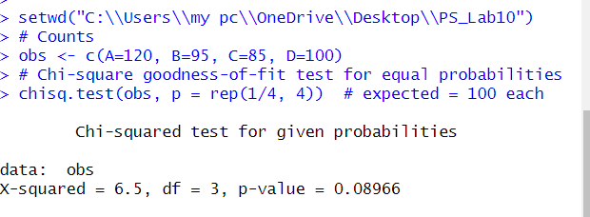

# iii) Conclusion

* At **α = 0.05**: p = 0.0897 > 0.05 ⇒ **Fail to reject H₀**. There isn’t enough evidence to say the snack choices differ from equal probabilities.